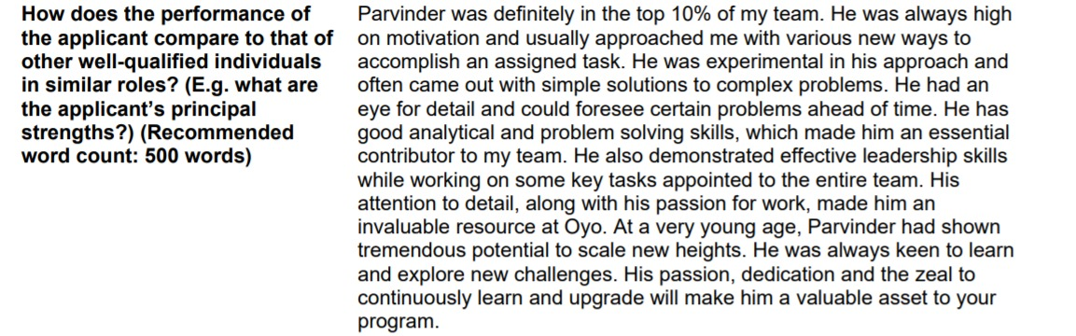

Parvinder has always been among the top 10% of the team members with outstanding skills and results. He was always highly motivated for any task and used to frequently come up with new ways to accomplish any task and discuss them with me. He preferred experimenting with several accomplishment approaches and often came up with optimized and easier solutions for any complex problem in hand. He always had his eyes on detailing and with that he was able to foresee several problems that might hit in the future. He was an always essential contributor to my team having an awesome skill-set in problem-solving techniques. His leadership skills too were highly appreciated all across the team whenever any short task was assigned, as he was the one to effectively handle everything. His concerns towards the details and his outstanding passion for the work made him a valuable resource and OYO. At such a young age, Parvinder exhibits fascinating potential to reach up to the new heights. He was always open to learning new things, explore new challenges, and experiment with several approaches to analyze the most optimal solutions. His dedication, passion, and determination towards the work, to learn new things, and to upgrade will make him the most valuable asset that your program will ever have.

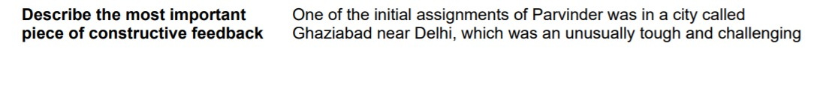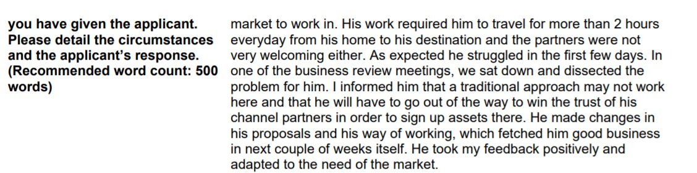

Parvinder’s one of the initial assignments was in Ghaziabad. It is a city near Delhi whose market is extremely tough and full of challenges. Due to his role, Parvinder had to travel for more than 2 hours per day to reach the assigned destination from his home, and tackle not so welcoming and kind partners. Initially, he struggled with all the tiresome tasks and role, but then soon we had a meeting which was about the business reviews. There we had a discussion about all the discrepancies, and we solved his issues. I suggested him that how traditional approaches are unsuccessful there always, and so will be for him too, and hence he must first try out of the box to win the partners’ trusts and then eventually reach the point to sign up the assets there. Parvinder instantly changed his proposals and adapted to the required changes. He changed his working ways as well as the approaching ways, and was able to fetch good business deals in just some couple of weeks. He positively responded to my suggestions and instantly adapted to the market needs of the locality.